Leasevail.com Notes and Changes:

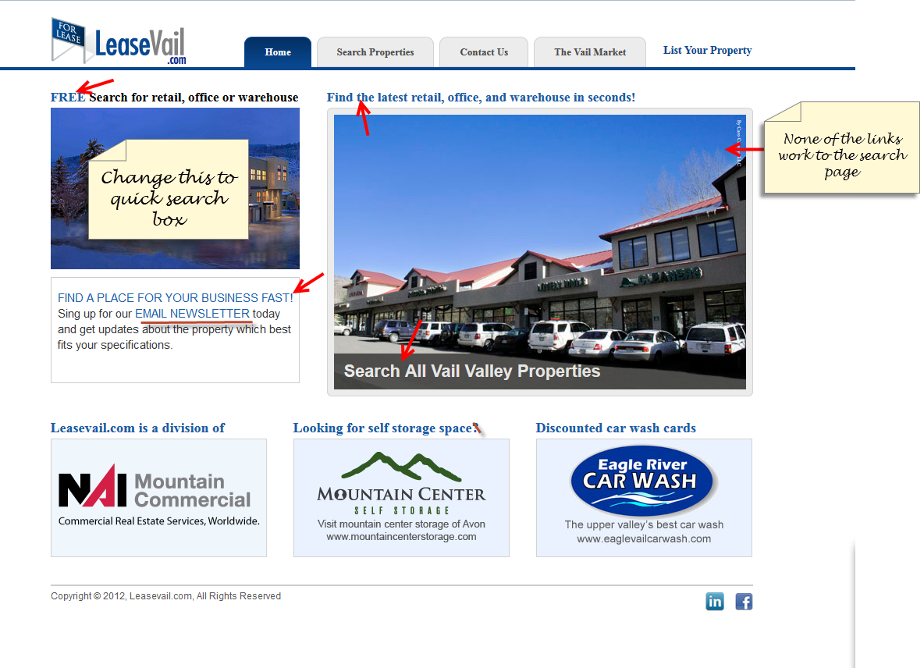
Home Page

- Links on photos to the search page do not work
- Please change the border around the main photo
- Get rid of “?” on storage space link
- Add Photos of Annex, Chapel Square, North Court, Northstar, Nott Station, and Concert Hall Plaza, - get rid of Car Wash : Please avail us content (We are unable to upload imges from wordpress admin. Error image is attached in mail )
- Connect “the newsletter” link to mailchimp.com : Please avail us Mailchimp details and form name which you wish to use.
- Remove the photo on the top left and replace with a quick search box similar to the image below : Which MLS service do you wish to use for it?
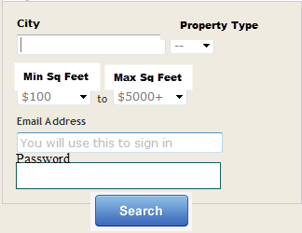

Search Properties Page:
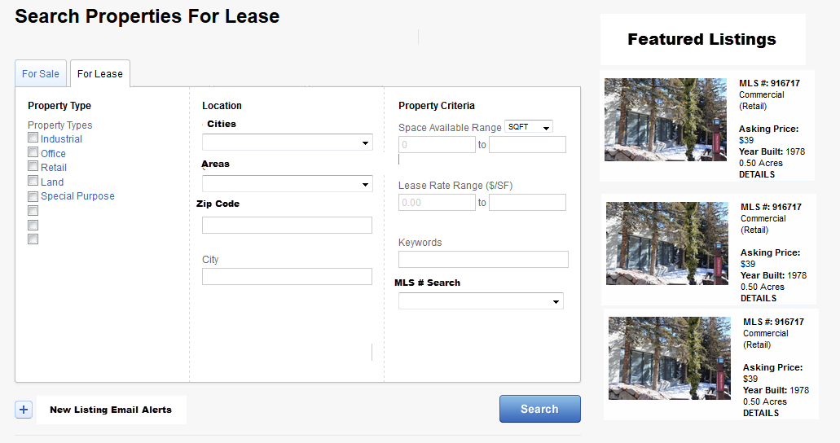

- There needs to be two pages
  - For Sale & For Lease – This should only be commercial property
- Above is a mockup of how the page should layout
- Results I want the search results for all searches to be displayed in a satellite map format
- Search by City, Areas, or Zip code
  - Property Criteria needs to be min and max size and price.
    - I do not want drop down menu I want them to input actual sizes
  - We need a keyords search if possible
  - We need and MLS # search
- Featured listings should be displayed on the actual search page
Which MLS service do you wish to use for it?

Contact Us Page:
- Title and Company should be optional fields on this form
- We need the NAI Mtn Commercial Logo and a link to the main site on this page

- The logo in the About Us portion is not displaying correctly
- We need to fix the mailing list so that it displays properly and links properly – this code was built in mailchimp.com: Please avail us Mailchimp details and form name which you wish to use.
- I want this page to a blog like the News page for Mtn Center Storage http://www.mountaincenterstorage.com/news/

Other Changes and Notes:
- We need Auto Responders on the sign up for our newsletter as well as the search page sign in.
  - We have created an auto responder in mailchimp for the newsletter sign up but need assistance setting it up.

